
Interview Record Form
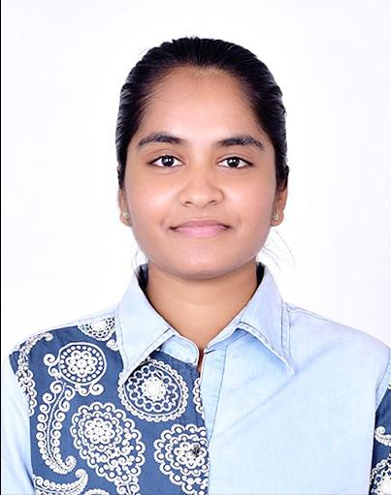

Name (AS PER THE PASSPORT or 10TH MARK SHEET):  Anjali T S S L | Date:  23-08-2025
Present Address:  Vidya Nagar Sowdhagar Colony 3rd cross Uma nilayam near Buda park Bellary  Pincode:583104 | Permanent Address:  D.No 7/A sri Lakshmi Venkateswara Nilayam Siddartha nagar , Infantry Road, Cantonment Bellary  Pincode: 583104
Mobile:  9840306768 | E-Mail ID:  anjalinaidu4444@gmail.com
Alternate Contact:  9632246729 | Alternate E-Mail ID:  tsslanjali@gmail.com
AADHAR NUMBER:  4149 8058 6950 | Source | Direct Applicant
Gender : Male  Female |  | Vendor/Agency (Vendor Name):
Date of Birth (DD/MM/YY):  04/09/2001 |  |  Referral (Name & SAP-ID): Veera & 52020040
Any Backlogs in the Education Yes/No : If yes, how many  No | Have you Worked in HCL before : Yes / No If Yes mention your SAP Code :  No
Skill:  Java,UI full stack,Springboot,REST API, React JS | 24x7 Work shift - Yes / No :  Yes
Total IT Exp. (in Yrs.):  1.8 yrs | Relevant Skill Exp. (in Yrs.):  1.7 yrs
Nationality:
Indian
Category of Position Applied For (To be filled by Recruiter)
Educational Background – Standard recognized full time degree or diploma’s only.

Qualification | Full Time FT/ Part Time PT/ Distance education DE) | College / Institute / University | Area of Specialization | Start Date MM/YY | Passed Out MM/YY | Grade  / %  Yes  Yes  Yes | Have Mark Sheet and Certificate YES/NO
X  Full Time FT  Full Time FT  Full Time FT |  | NANDI SCHOOL BELLARY | General Curriculum | 07/2016 | 04/2017 | 7.6
XII / Diploma |  | PUPIL TREE PU COLLEGE | PCMC | 07/2018 | 03/2019 | 76
Graduation |  | BELLARY INSTITUE OF TECHNLOGY & MANAGEMENT | COMPUTER SCIENCE & ENGINEERING | 08/2019 | 05/2023 | 7.9
Post-Grad

Employment Details: (Starting with your present or most recent employer, please list of all your past employments)




Sl.  No.  1 | Company Name | Position Held (While leaving)  Programmer Analyst | From (DD/MM/YYYY)  13/12/2023 | To (DD/MM/YYYY) | Reasons for leaving | Have Offer letter (OL)/ Relieving letter (RL)/ Experience Certificate (EC)  Please Tick
 | Cognizant Technology solutions India Pvt ltd |  |  | 05/10/2025 | CAREER IMPROVMENT | OL | / RL | / EC
 |  |  |  |  |  | OL | / RL | / EC
 |  |  |  |  |  | OL | / RL | / EC
 |  |  |  |  |  | OL | / RL | / EC
 |  |  |  |  |  | OL | / RL | / EC

Additional Relevant Diploma / Certificate / Training (Part time, full time or through correspondence)

Certificate / Course | Institute | Subject Area | Duration (Months) | Year of Completion

CTC Details | Fixed Comp:  4,31,244 | Variable Comp: | Additional Allowance  19,500 | Total Annual CTC  4,50,744
Expected CTC:  8,00,000 |  | Notice Period:  90 Days

PROFESSIONAL REFERENCES:
(Please give references of people, who worked / working as your Lead / Reporting Manager/supervisor)

Name | Occupation | Contact & email ID | Relation with HCL Employee
Naggari Sarath kumar | Software Employee | 9494481115 & Nagaarisarath04@gmail.com | Friend
Satyajit Bihari | Software Employee | 8658794741 & satyajit064@gmail.com | Colleague and Friend

Declaration:
I, declare that the information provided by me above is true to the best of my knowledge and belief. Any misinterpretation or omission in above details renders be liable and I will abide the action taken by the company.
Anjali TSSL

Date: 25/08/2025 Signature:
Place: Bangalore

